Project Title: Women and Children Safety Hand Band With the help of own Satellite in IoT(Internet of things)

Project Design Phase-I - Solution Fit

Team ID: PNT2022TMID11856

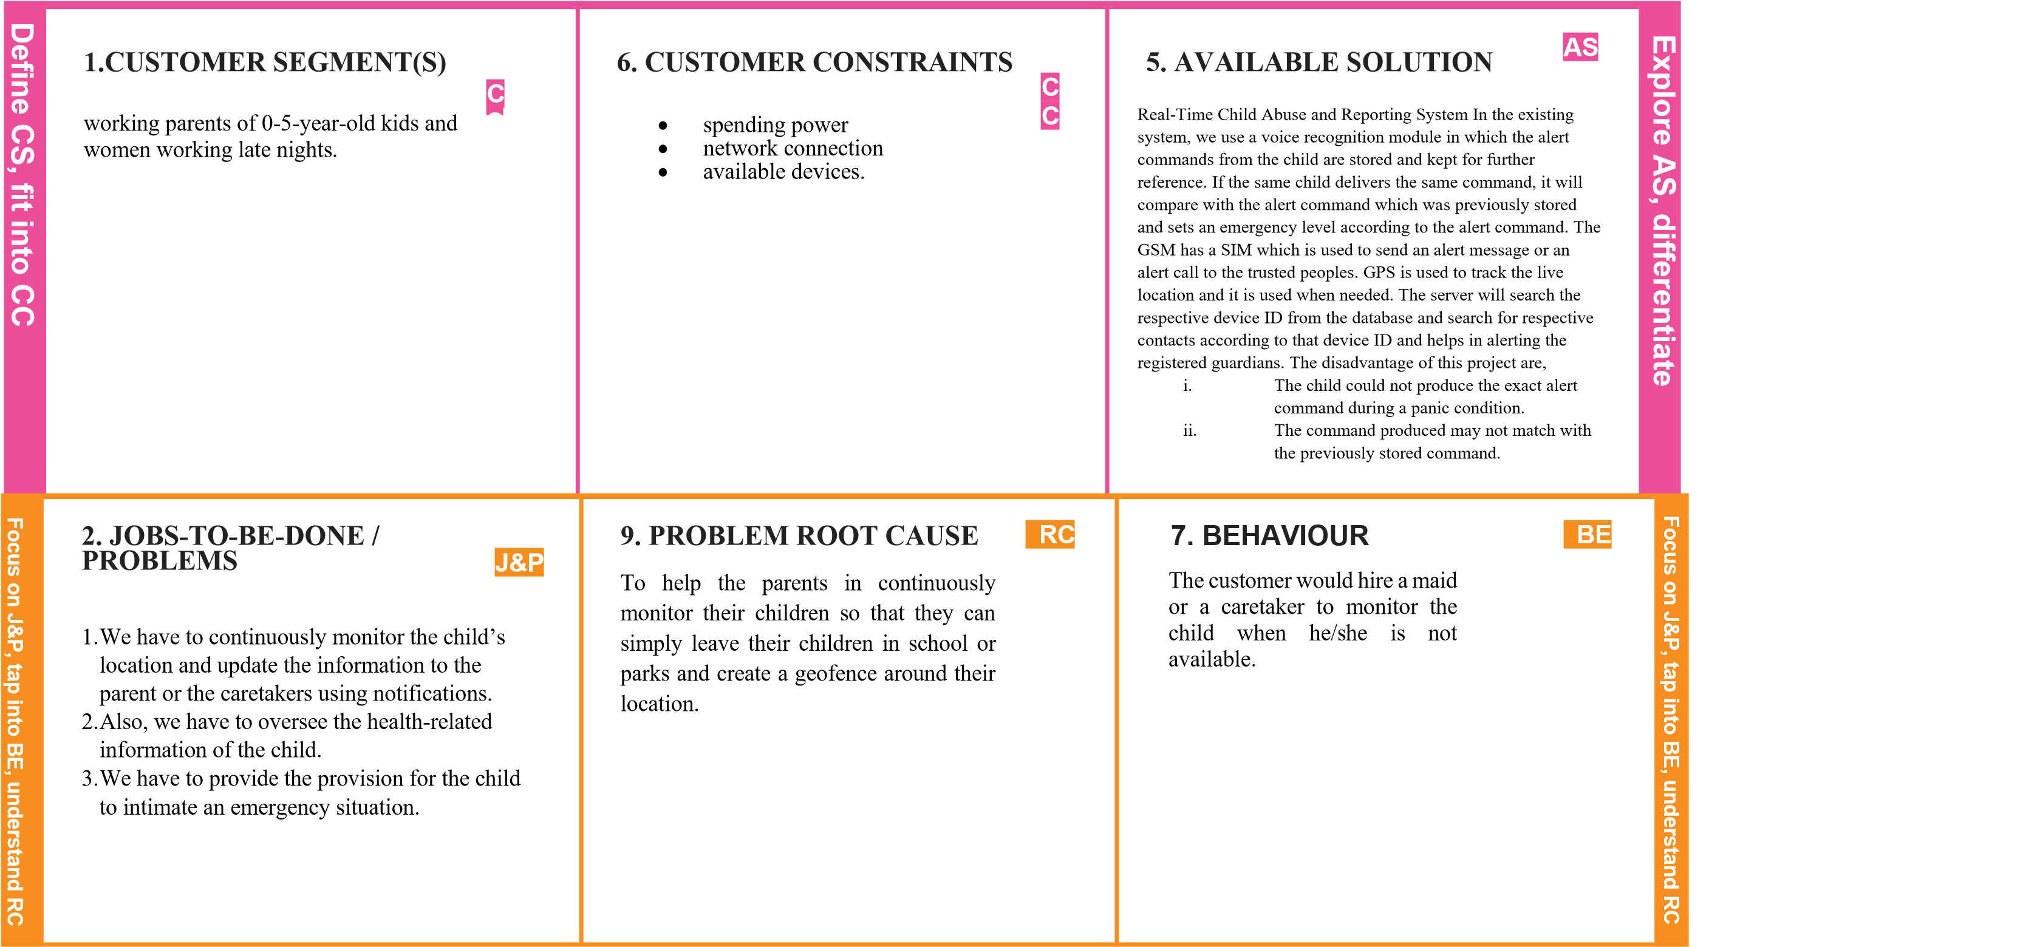

|  |  |  |  |  |  |  |  |  |  |  |
| --- | --- | --- | --- | --- | --- | --- | --- | --- | --- | --- |
| I  d e n ti  f  y s  tr  o n  g  T  R  &  E  M |  | | | 10. YOUR SOLUTION | |  |  | | |  |
| 3. TRIGGERS | TR |  | 8. CHANNELS of BEHAVIOUR | CH |  | I  d e n t  i  f  y s  t  r  o n  g  T  R  &  E  M |
| What triggers customers to act?  i.e. seeing news |  |  | 8.1 ONLINE | |  |
| * To address the problem statement, a Smart Hand Band wearable device is being developed that will allow them to communicate with others without the use of a mobile network by utilising a cube satellite. * When Women/Children sense insecurity in this proposed work, they must press the trigger. * When the trigger is pressed, the GPS begins sharing the current location with the CubeSat via LoRa transceiver, also followed by a call and SMS to the police department and selected emergency contact numbers via GSM module. | SL |
| of children getting kidnapped and missing due to lack of monitoring. |  |  | What kind of actions do customers take online? Extract online channels from #7    8.2 OFFLINE  What kind of actions do customers take offline? Extract offline channels from #7 and use them for customer development. | |  |
| 4. EMOTIONS: BEFORE / AFTER |  |  |  | |
| EM |
| lost, insecure > confident, in control - use it in your |  |  |
| communication strategy & design. |  |  |
|  |